# Lesson 5: Analyzing Results

## Introduction

* Until now, we have covered
  + - What metrics to use to evaluate your change
    - Characterized those metrics
    - You have designed and preliminarily sized your experiment
* We will now talk what you can conclude from the data that you’ve captured
* Analyze the results
* Determine what you can and you cannot conclude

Four major section-

* 1. Sanity Checks
  2. Single Metric
  3. Multiple Metrics
  4. Gotchas



**Notes on running A/B tests**

There are a lot of different platforms for running A/B testing, or you can “roll your own.” There are full-service platforms for your website (or even for email or client side sales apps) - you can see a comparison table here. There are also more component parts approaches, where you can use a toolkit with frames, randomization, or other features to experiment (and log the results).

Link: <https://en.wikipedia.org/wiki/A/B_testing#A.2FB_testing_tools_comparison>

## Sanity Checks

* Once the experiment run is completed, do not run to summarize the results.
* First do Sanity checks to ensure your experiment was run properly
* You can check these using **Invariant Metrics**. There are two main types of **Invariant Metrics**-
  1. **Population sizing metrics** (based on your unit of diversion)
     + You are basically checking that your experiment and control populations are actually comparable
  2. **Actual Invariants**
     + Those metrics that shouldn’t change when you run the experiment and you want to test they didn’t change

## Choosing Invariants

* First step to sanity checking our results is choosing a set of invariant metrics
* A good invariant metric would remain same for both experiment and control group

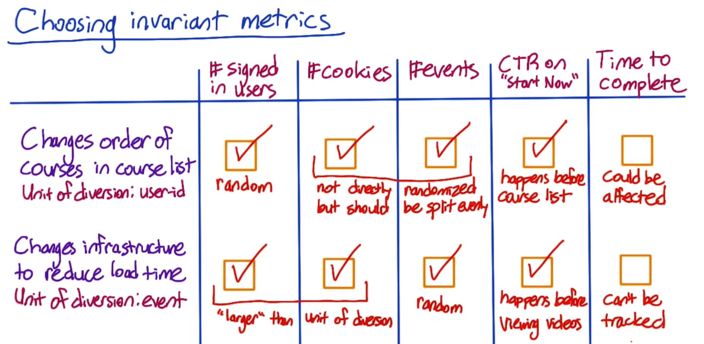

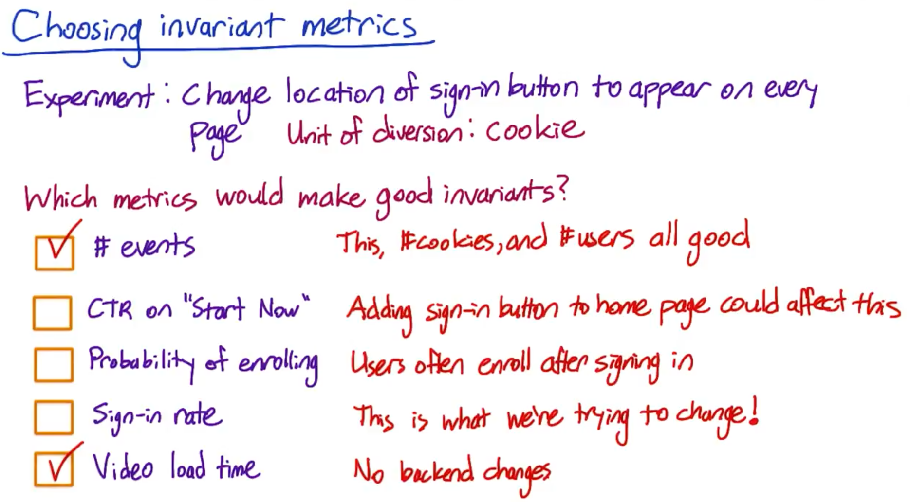

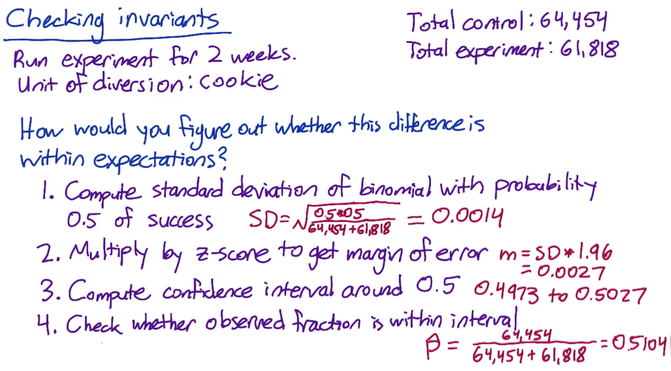



### Quiz:

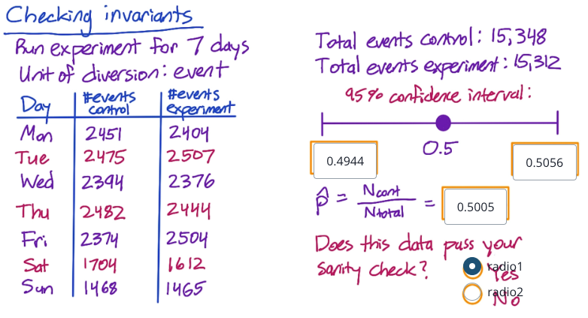

## Sanity Checking wrap-up

* If sanity checks fail, do not process analyzing the experiment results. The conclusions would certainly be incorrect.
* To figure out the failure of Sanity check, try the following-
  + - Analyze the reason of sanity checks fail
    - Something gone technically wrong, work with engineers to understand these- experiment diversion, experiment infrastructure …
    - Retrospective analysis
    - Use pre-periods and post-periods
    - Most common reasons is “data capture”

## Single Metric



## Single Metric: Introduction

**What not to do if your results aren't significant**

Carrie gave some ideas of what you can do if your results aren't significant, but you were expecting they would be. One tempting idea is to run the experiment for a few more days and see if the extra data helps get you a significant result. However, this can lead to a much higher false positive rate than you expecting! See this post for more details. Instead of running for longer when you don't like the results, you should be sizing your experiment in advance to ensure that you will have enough power the first time you look at your results.

Link: <https://www.evanmiller.org/how-not-to-run-an-ab-test.html>

## Single Metric: Example

Practical significance boundary (d min) = minimum change you want to observe before launching a test

Margin of error = standard error * z_value

Here, we are computing

1. Confidence interval of the effect size, i.e. there is no difference between the CTR In the control and experiment group
2. Doing sign test on the day-by-day data

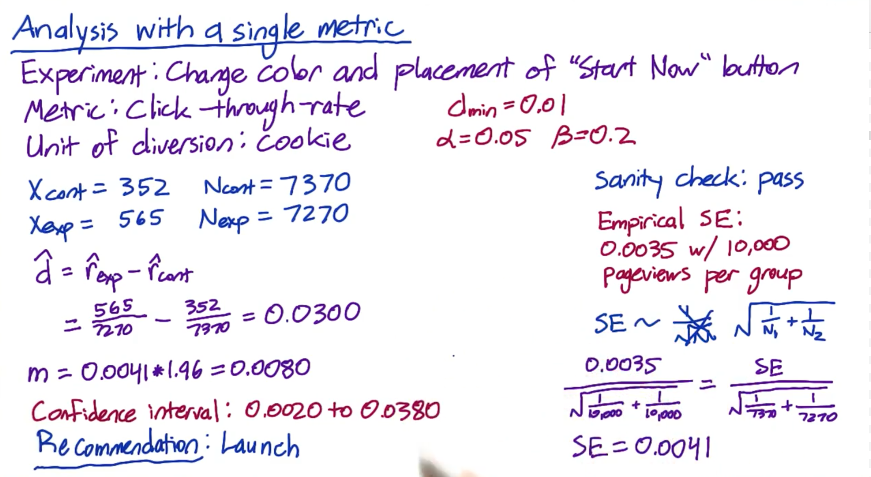

* Here we used empirically estimated Standard error provided to us by Audacity: 0.0035 with 10000 pageviews per group

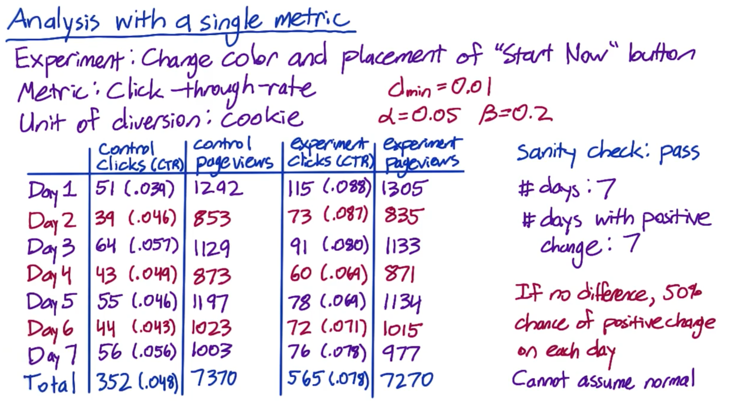



* After doing sign test using binomial distribution- two-tailed P value = 0.0156
* This is < 0.05, hence recommendation is to launch

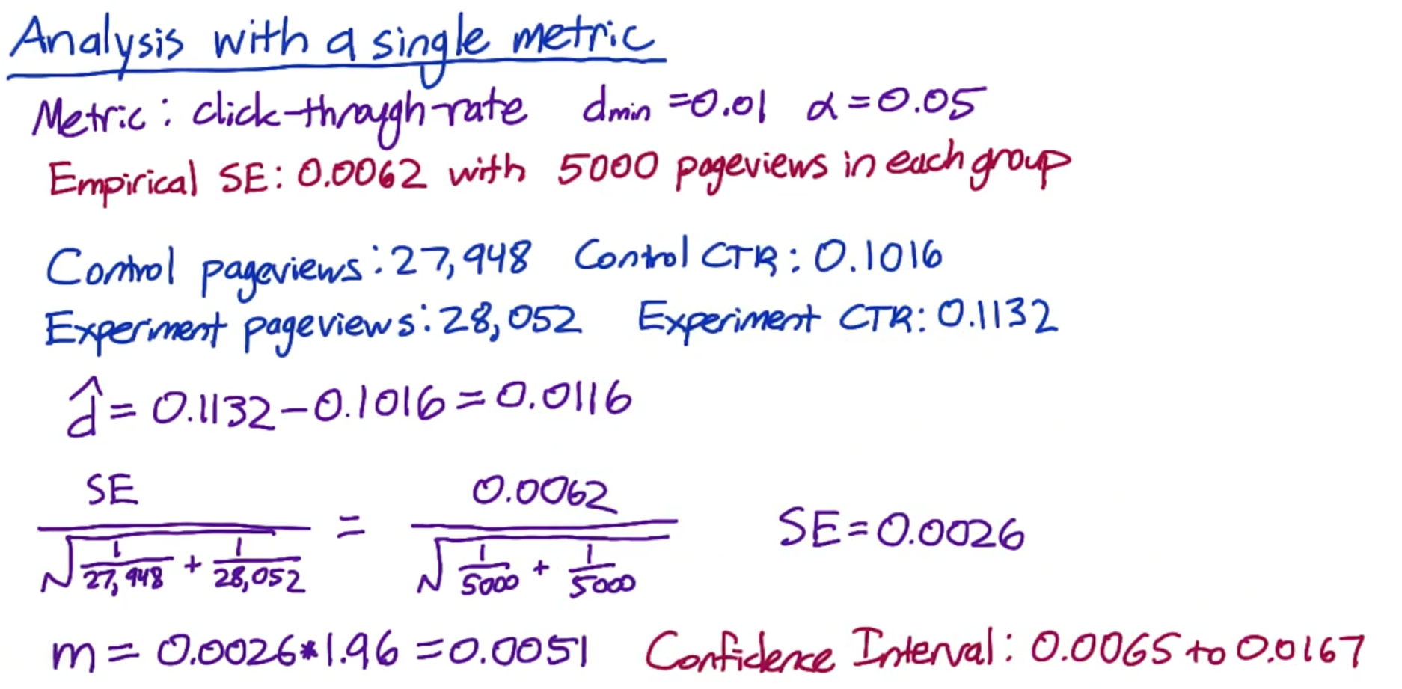

* The results are significant as do not contain 0. But, they do contain significance boundary (0.01), hence at 95% Confidence level, we are not sure of the effect that we expect to observe.

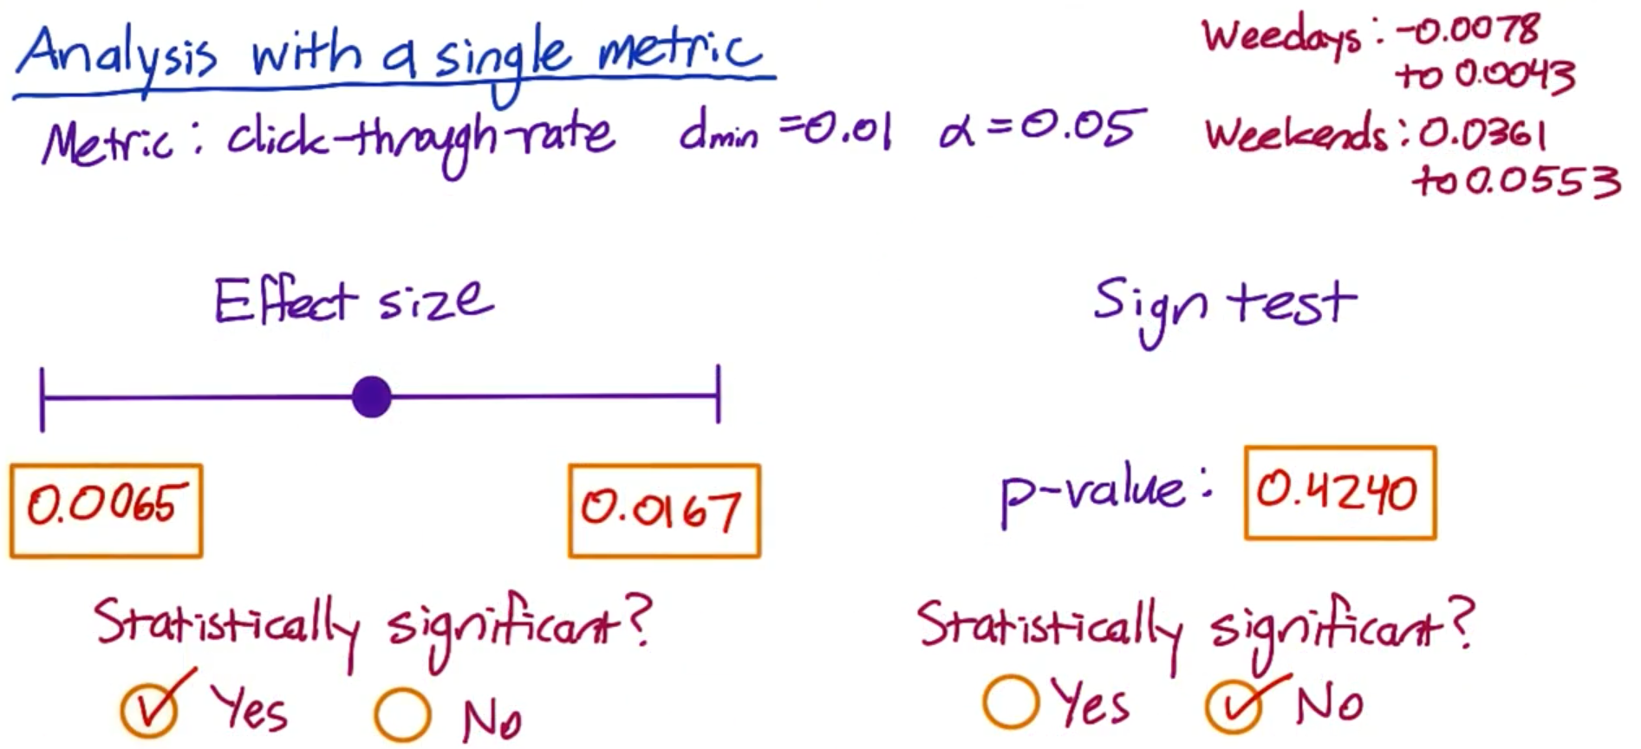

* We calculate p-value using online calculator here for binomial- <https://www.graphpad.com/quickcalcs/binomial1.cfm>
* P-value suggests that the results are not significant.
* Also, when we look at weekdays and weekends separately and plot their CI as well as p-value
* Both the results suggest that the difference is significant on weekends, greater than practical significance boundary
* Sign test has lower power than the effect size test, which is frequently the case for non-parametric tests

## Single Metric: Gotchas

What do when sign test and hypothesis test don’t agree? Or what if when you have significant results on weekends but not weekdays?

* Take a critical look about how your feature functions – Is it really operating differently for different sub-groups
* Simpson’s paradox
  + - It means if there’s a bunch of different subgroups in your data. And within each sub-group, the results are stable, but when you aggregate them all together, it’s the ix of subgroups that actually drives your result.
    - Example- Graduate admissions at Berkley

## Gotchas: Simpson’s Paradox

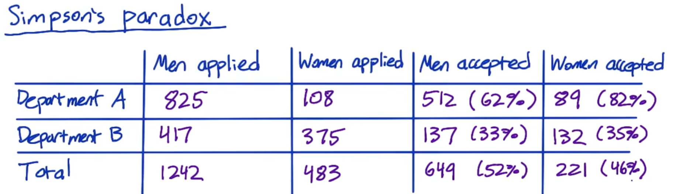

* Women acceptance rate is higher in both Dept A and B, but overall, it’s lower than men. This is called Simpson’s paradox.
* Similar thing could happen to any other AB test.
* Example- At aggregate level, the experiment group has a lower CTR than the control group. But then, if you break it down by say, new users and experienced users, you see the reverse.

Simpson’s paradox Quiz

* Total count in the control group for new users is too low as compared to in the experiment group, causing the Simpson’s paradox.

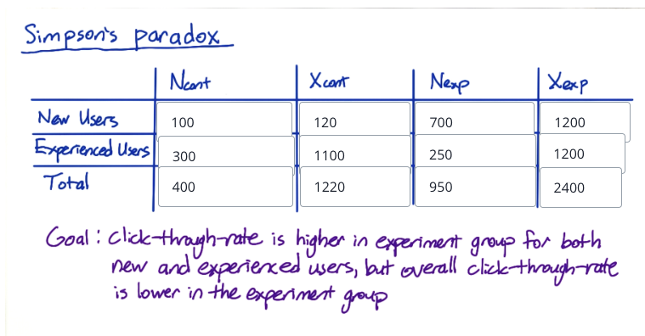

## Multiple Metrics



## Multiple Metrics: Introduction

What changes when you have multiple evaluation metrics than just one?

* The more things you test, the more likely you are to see significant differences just by chance.
* For example- if you’re testing 20 metrics and CI is 95%, then you have at-least 1 case that would be significant only by chance.
* Although this is a problem, but you’re not sunk because it shouldn’t be repeatable.
* There’s another technique for this called **Multiple Comparisons** that adjusts your significance level, that it accounts for how many metrics or how many different tests you’re doing.

**Multiple comparisons**

Like Carrie mentioned, as you test more metrics, it becomes more likely that one of them will show a statistically significant result by chance. There will be more details about this in the next videos. You can also find more information in this article.

Link: <https://en.wikipedia.org/wiki/Multiple_comparisons_problem>

## Multiple Metrics: Example 1

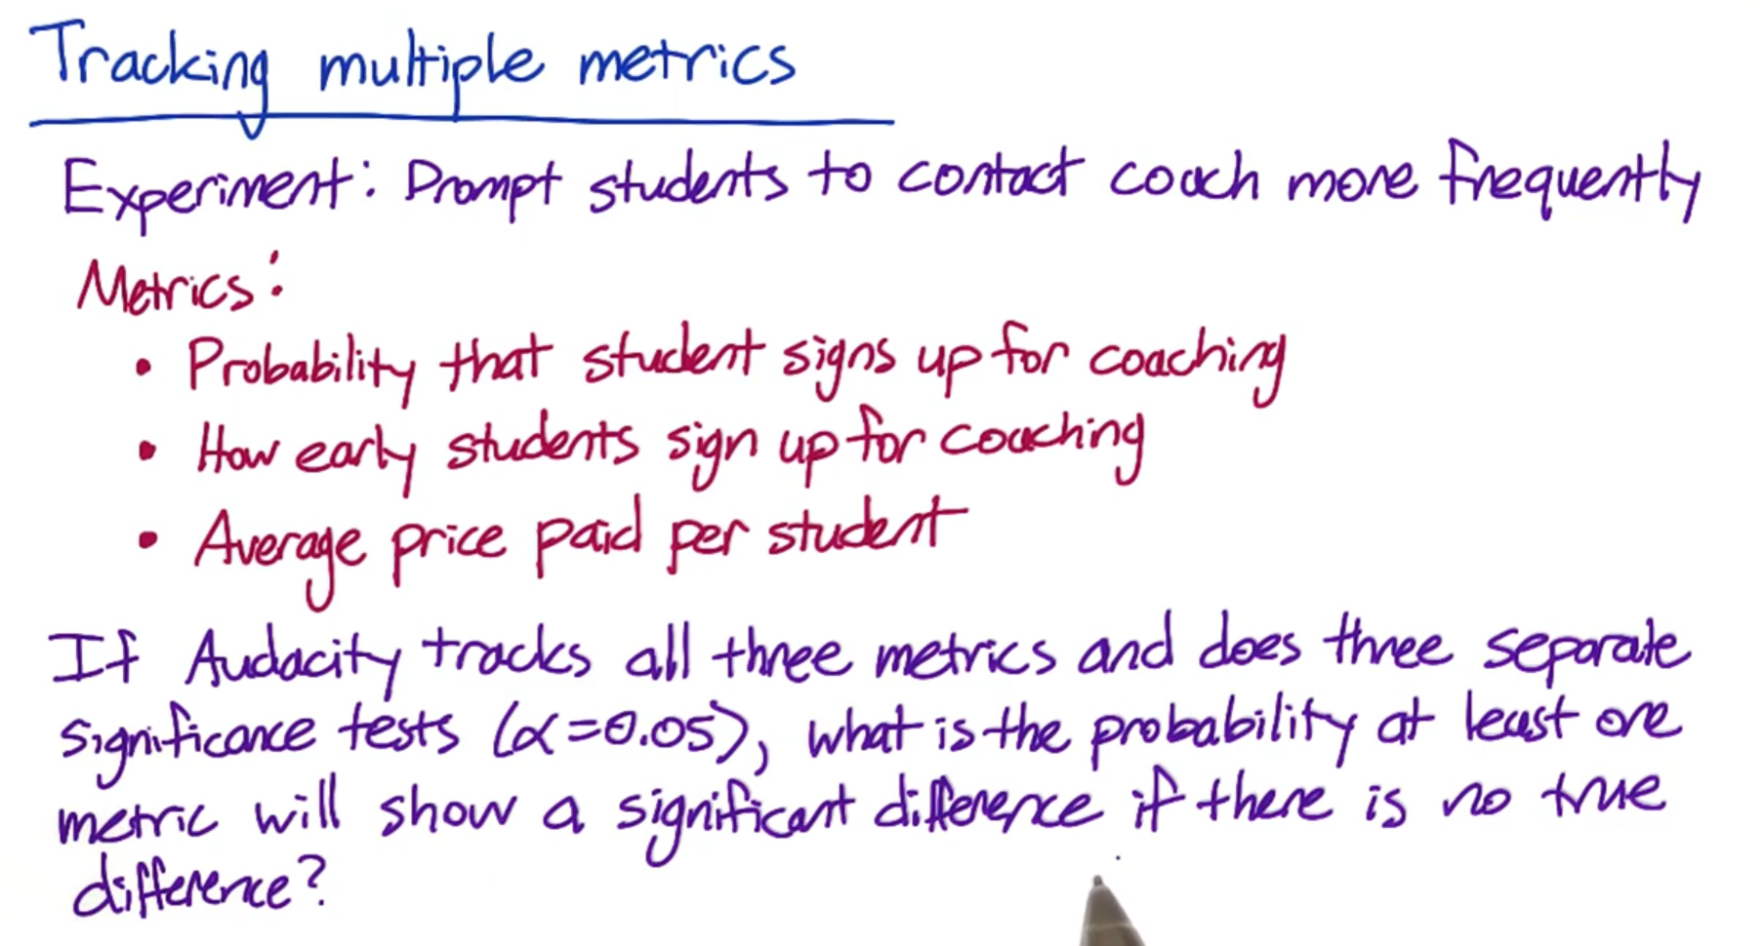

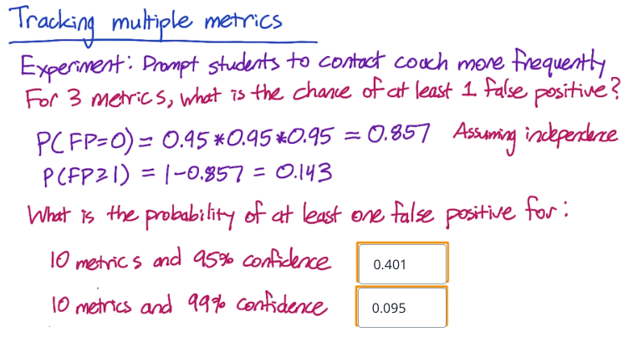

## Multiple Metrics: Example 2

* Main problem with tracking multiple metrics is that the False Positives becomes more common as you increase the number of metrics you’re measuring.

Solution- Use higher confidence level for each metric.

* We can calculate alpha using the approach above, however, our method assumed that **metrics were independent**
* Other method used is called **Bonferroni correction**
  + - It’s simple and have no assumptions
    - Also, it is conservative and guaranteed to give alpha overall at least as small as specified

**Problem with Bonferroni Correction**

* Often, you’ll be tracking metrics that are corelated and all tend to move at the same time
* In that case, this method is too conservative
* Which means, you’ll have to launch fewer experiments that you would like

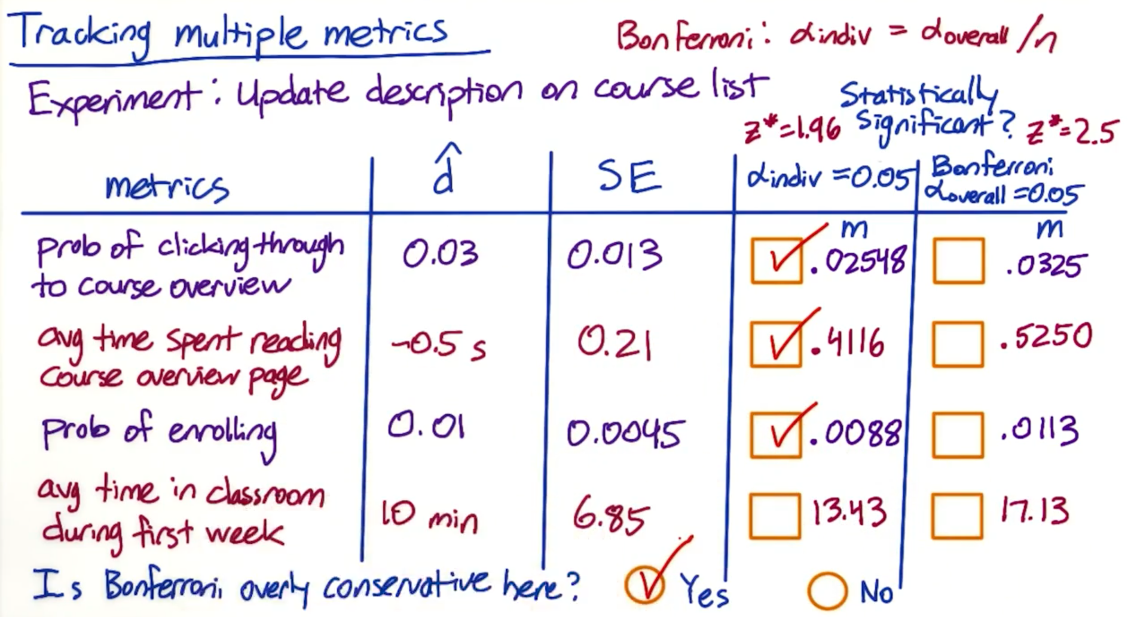

* If margin of error is smaller than the observed difference, which means the CI won’t include zero. Hence, the difference is significant.
* We found that 3 out of 4 metrics had significant difference at alpha 0.05, but none were significant using Bonferroni.
* In the above case, Bonferroni correction is too conservative. If the course description was an improvement, then it makes sense that it could cause more than one of these metrics to move they’re probably more likely to move together.
* A more sophisticated method should be used that takes into account that the metrics are likely to be corelated.

**Bonferroni correction**

You can find more details about the Bonferroni correction, including a proof that it works, in this article.

Link: <https://en.wikipedia.org/wiki/Bonferroni_correction>

## Multiple Metrics: Example 3

* There’s also another strategy that’s different than just choosing an individual alpha.
* Ideally I would have decided what ethod to use when designing the experiment and taking that into account when sizing.
* Practically, this type of situation may come down to a judgemen call.

Different Strategies:

* The methods that we have used up to now try to control the probability that any metric shows a False positive, calles overall-alpha.
* Overall alpha is more commonly called **FWER (Family wise error rate)**
* Another approach is to loosen that and say you are okay with some FP, even wiyh a high probability as long as there’s not too many.
* So, in this case you try to control what is called the **FDR (False discovery rate)**
* **FDR =** Number of false positives (i.e. no of time you reject the null, when null was true) divided by total number of rejections of the null (both valid + invalid)
* **FDR** is measuring out of all of the rejections of the null, i.e. all of the metrics that you declare to have a statistically significant difference, how many of them had a real difference as opposed to how many were FPs.
* This only makes sense if you have a huge number of metrics, say hundereds.
* Suppose you have 200 metrics and you cap FDR at 0.05. This means, you are okay with 5 FPs and (% TPs in every experiment. The FWER or the overall alpha in this case will be , as you at least 1 FP every time.
* So, if you’re trying to detect significant changes across a large number of metrics, then capping a FDR instead of the FWER can be a lot lenient.

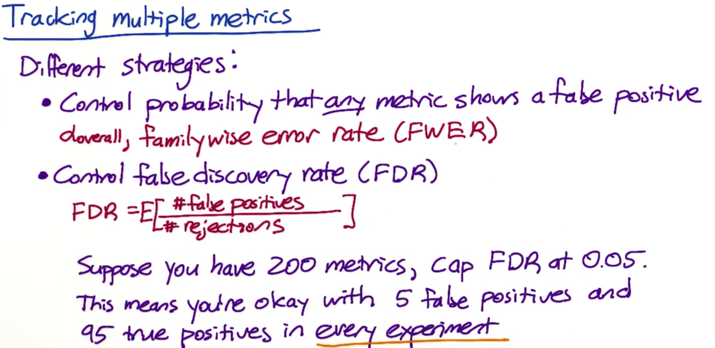

## Analyzing multiple metrics

* Other methods that can be used for multiple metrics are here

Bonferroni Correction - <https://en.wikipedia.org/wiki/Bonferroni_correction>

Closed testing procedure - <https://en.wikipedia.org/wiki/Closed_testing_procedure>

Boole’s Inequality- <https://en.wikipedia.org/wiki/Boole%27s_inequality>

Holm–Bonferroni method- <https://en.wikipedia.org/wiki/Holm%E2%80%93Bonferroni_method>

Multiple comparisons problem- <https://en.wikipedia.org/wiki/Multiple_comparisons_problem>

False Discover rate - <https://en.wikipedia.org/wiki/False_discovery_rate>

Once we know what metrics have significant changes, then you have to decide what your results do and don’t tell you.

* If you have statistically significant results, that means you are unlikely to have zero impact on user experience.
* Now, it’s important to know if you understand the change? And if you want to launch the change?
* Ask yourself the following 3 questions-
  1. Do you have statistically significant and practically significant results to justify the change?
  2. Do you understand what that change has actually done with regards to user experience?
  3. Is it worth it?

## Gotchas

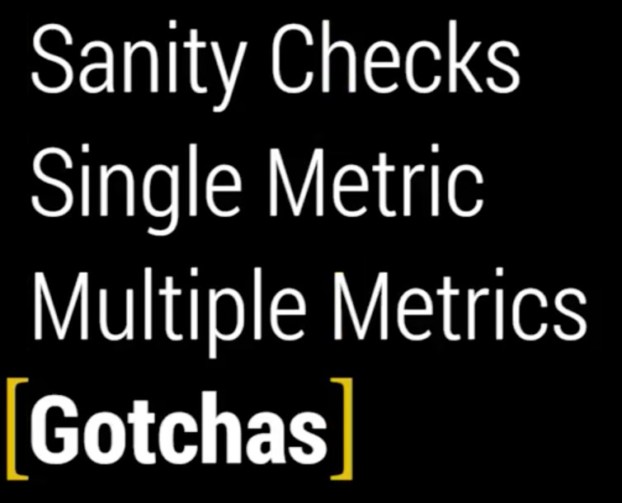

## Gotchas: Changes over time

Is it ever a good idea to ramp up your experiment? i.e. You start with 1% of your traffic as being diverted to the experiment group, but then gradually increase that until your feature is fully launched.

* Yes, it’s always good to ramp up.

There is one interesting complication or Gotcha that we have to deal with in our ramp-up wherein so that the effect many actually flatten out as you ramp up the change.

* So, even if the initial effect was statistically significant, there could be some simple reasons as your effects are not repeatable.
* For example- seasonality effect. When students go on summer vacation, behavior across broad swatch of Internet changes. And once they come back from holidays, it changes again.
* One way to capture these seasonal or event-driven impacts is called a **Holdback.**
* Idea behind Holdback is to launch the change to everyone except for a small holdback (set of users who don’t get the change) and then you continue comparing their behavior with the control group.
* Other effects could be novelty effect or change aversion effect. Cohort analysis can help.

## Lesson Learned

* Double-triple check that your experiment was set up properly
  + - Check end variance
* Do overall business analysis
  + - Cost of managing the change
    - Are there customer support or sales issues